Utilizing open-source reinforcement learning environments for implementation of Deep Q-learning

Colby Wilkinson,, Mark Dalton
Naval Undersea Warfare Center Division Newport

In recent years, Reinforcement Learning (RL) algorithms have been used to train autonomous agents to complete tasks in complex environments at human-user proficiency levels. Using RL in Navy specific contexts require simulating environmental conditions that an autonomous agent uses to learn to make optimal decisions. In this paper, we utilized an open-source environment, PuckWorld, from the Python Learning Environment module, to train an autonomous agent to navigate an environment with both targets and keep-out areas. We utilized Deep Q-Learning (DQN) to train our agent. This exercise demonstrated the value in using open-sourced environments to set up our training process and model structure.

Introduction

Recent advancements in reinforcement learning (RL) has led to the development of autonomous agents able to compete with humans at complex games such as Chess, Go, and Texas hold ‘em^{1–3}. While these rapid developments have surprised even the most optimistic proponents of RL, practical applications in real-world settings have not materialized at the same pace⁴. One hindrance to widespread adoption of RL in the Navy is the requisite effort to produce a high-fidelity simulation environment to train an autonomous agent. In this paper we utilize an open-source environment, PuckWorld, which is part of the Python Learning Environment⁵, to implement Deep Q-Learning (DQN). Leveraging this open-source environment allows us to experiment with different model inputs and architectures, alter reward structures and tune agent training procedures before investing resources in developing a custom environment for our problem space.

Previous Research

The use of DQN to train autonomous agents to make optimal decisions in complex, continuous environments is well-establised⁶. Previous research in this area includes training autonomous agents to play Atari game (such as Space Invaders) using either the game state or the screen pixels as sensory inputs to a deep neural network⁷. Real-world applications of Deep Learning in RL include robotics control and unmanned aerial vehicle (UAV) flight^{8,9}.

Methods

There are numerous open-source environments available to researchers who wish to implement DQN. With this in mind, we wanted to use an environment that had some similarities to potential Navy use cases. PuckWorld, part of the PyGame Learning Environment, was originally developed by Andrej Karpathy while he was a doctoral student in Computer Science at Stanford University. The environment consists of an agent that is rewarded for navigating to the green puck on the screen while avoiding the red puck. A snapshot of the environment is presented below in figure 1.


Figure 1: Frame of PuckWorld, part of the PyGame Leaning Environment

We used PuckWorld in this experiment due to its simple implementation and its similarity to several Navy use cases, such as UxV navigation, in a setting where certain targets are to be avoided while others need to be investigated. Furthermore, PuckWorld allows for custom state space processing, enabling us to alter what information is available to the agent to make decisions. Below, in table 1, PuckWorld parameters are detailed.

Table 1: PuckWorld Environment
State | - Position: X,Y coordinates  - Bearing: relative bearing to both green and red pucks  - Range: distance to both green and red pucks
Reward | [+] proximity to green puck  [-] within red puck halo
Actions | - Thrust left, right, up, down  - Thrust decays over time
In this experiment, we trained our agent by generating random PuckWorld configurations for each iteration. Each iteration would start with the agent (blue puck) in the top left-hand corner of the scree, the red puck in the bottom right, and the green puck randomly placed on screen. The red puck has perfect information at each time step regarding the location of the agent, and thus moved in the direction of the agent. Each iteration lasted for 250 time steps, a sufficient duration for the agent to receive feedback based on proximity to the red and green pucks.

To train our agent to navigate around the red puck while seeking the green puck we used DQN. Q-learning is an RL method that seeks to learn the best possible action given the environments current state¹⁰.

RL is a sub-section of machine learning where agents use experience to derive optimal policies. Figure XX below gives a simple representation of the training process for an RL-agent: the agent takes action, observes the reward and the new environment state, and updates the decision making process.

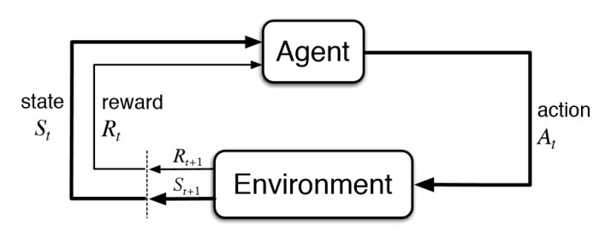

The Q-learning algorithm aims to estimate the long-term, discounted sum of rewards for each possible action given a state representation. The Q-learning algorithm uses a variant of the Bellman Equation, shown below, to update Q-values for each state representation during training. Once the learning algorithm converges (under certain conditions) the optimal policy is found by choosing the action with the maximum Q-value for each state representation¹¹.

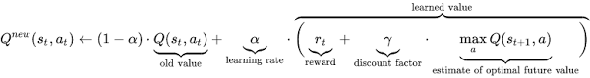

DQN is a function approximation method, where the agent uses a neural network to estimate a state’s Q-value (output) given a vector representing the environment’s current state. To train a neural network to accurately estimate each action’s Q-value given a state vector, we aim to minimize the mean-squared error between the Q-value prediction and the Q-value target. The details are beyond the scope of this paper, but, in short: we use the agents experience to simultaneously estimate Q-value targets and update the weight and bias parameters of the neural network used to predict Q-values, seeking to minimize the squared distance between Q-value prediction and Q-value target.

Our training used the parameters presented in table XX below:
Table XX: DQN Training Parameters
Epsilon | Start: 0.35, decay 1% every other iteration to minimum of 0.01
Gamma | 0.95
Iterations | 10,000
Terminal | 250 time steps
Memory Size | 10,000
Batch Size | 20
The epsilon parameter is the probability the agent takes a random action at each time step rather than selecting the action with the max Q-value. To encourage the agent to explore new actions, we initially set the exploration parameter epsilon to 0.35. As the agent gains experience necessary to improves Q-value predictions, the exploration parameter is decayed to 0.01, at which point the agent is exploiting its experience to make optimal decisions. The gamma parameter is the discount factor, and accounts for the agent’s preference of near-term rewards relative to long-term rewards. We used experience replay, where a random subset of state-action-reward vectors are used to update our DQN agent network via gradient descent, with batch size 20 to account for correlations between successive observations, which can cause unstable learning¹². Each of the 10,000 training iterations lasted 250 times steps.

The neural network architecture, displayed below in figure XX, consisted of one hidden, fully connected layer using relu activation. The output layer, which predicted the Q-value for each possible action, used linear activation.

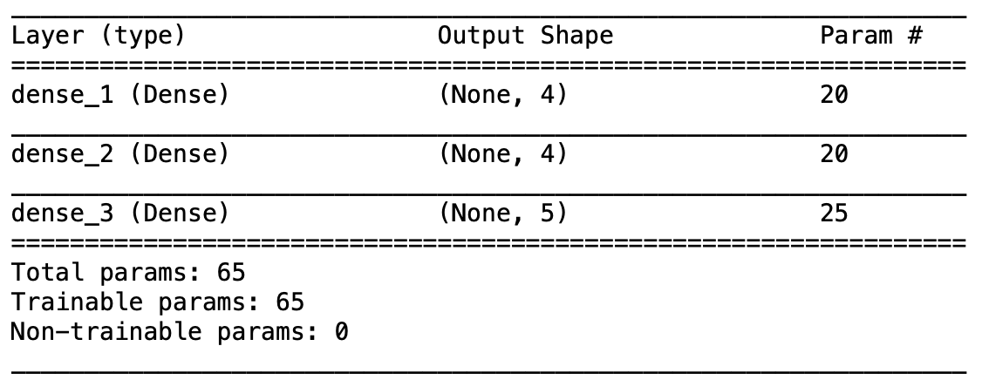

Results

Figure XX below plots the rewards achieved by the agent over 10,000 training iterations. The orange series is a moving average of rewards with window size 25, while the green curve represents a moving average of rewards with window size 1000. As the plot shows, the agent improves performance from start to roughly iteration 4,000, after which performance plateaus. Visual evaluation of the trained agent confirmed the agent, for the most part, avoids the red puck while hovering around the green puck.
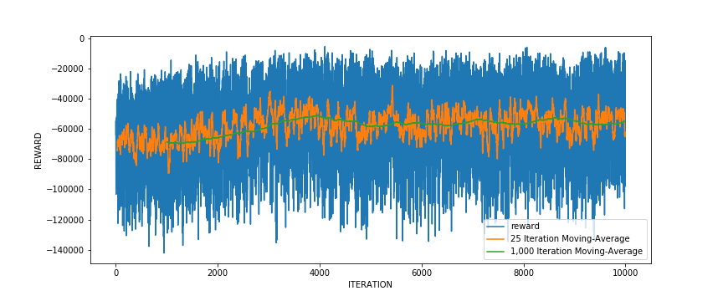Figure XX: reward curves for DQN agent across 10,000 training iterations

A known challenge in DQN is the need for extensive training iterations¹². Given our agent’s performance has room for improvement, future work should focus on adjusting training parameters such as learning rate decay, DQN model structure and length of each iteration.

Conclusions

The intention of this research is two-fold: demonstrate the value of open-source RL environments as a placeholder until higher-fidelity environments have been created, and 2) offer an implementation of DQN for PuckWorld.

While PuckWorld has similar features to potential Navy use-cases (UxV navigation, Torpedo evasion, for example) it is also relatively easy to adjust the PuckWorld environment code to better reflect different applications. Numerous other open-source environments are available from modules such as OpenAI gym and PyGame Leaning Environment. Furthermore, open-source RL environments can aid researcher understanding of the feasibility of training an autonomous agent to perform in complex environments given the information that will likely be available to the agent.

Our implementation of DQN demonstrates the how to train an agent in a complex environment. Future work in this area includes improving agent performance through adjusting training parameters and adjusting environment conditions, such as number of targets and reward structure to explore effects on agent performance. We also plan on creating an environment from scratch using open-sourced modules to train autonomous agents in use-cases generated from stakeholder engagement.

References

1. Silver D, Hubert T, Schrittwieser J, et al. A general reinforcement learning algorithm that masters chess, shogi, and Go through self-play. Science (80- ). 2018. doi:10.1126/science.aar6404
2. Ramirez A, Reinman S, Norouzi N. PokerBot: Hand Strength Reinforcement Learning. In: IEEE International Symposium on INnovations in Intelligent SysTems and Applications, INISTA 2019 - Proceedings. ; 2019. doi:10.1109/INISTA.2019.8778267
3. Silver D, Huang A, Maddison CJ, et al. Mastering the game of Go with deep neural networks and tree search. Nature. 2016. doi:10.1038/nature16961
4. Kormushev P, Calinon S, Caldwell DG. Reinforcement learning in robotics: Applications and real-world challenges. Robotics. 2013. doi:10.3390/robotics2030122
5. Karpathy A. PyGame Learning Environment: PuckWorld. https://pygame-learning-environment.readthedocs.io/en/latest/user/games/puckworld.html.
6. Tesau C, Tesau G. Temporal Difference Learning and TD-Gammon. Commun ACM. 1995. doi:10.1145/203330.203343
7. Mnih V, Kavukcuoglu K, Silver D, et al. Human-level control through deep reinforcement learning. Nature. 2015. doi:10.1038/nature14236
8. Levine S, Finn C, Darrell T, Abbeel P. End-to-end training of deep visuomotor policies. J Mach Learn Res. 2016.
9. Imanberdiyev N, Fu C, Kayacan E, Chen IM. Autonomous navigation of UAV by using real-time model-based reinforcement learning. In: 2016 14th International Conference on Control, Automation, Robotics and Vision, ICARCV 2016. ; 2017. doi:10.1109/ICARCV.2016.7838739
10. Sutton RS, Barto AG. Reinforcement Learning: An Introduction. IEEE Trans Neural Networks. 1998. doi:10.1109/tnn.1998.712192
11. Melo FS. Convergence of Q-learning: A simple proof. Inst Syst Robot Tech Rep. 2001. doi:10.1016/j.aqpro.2013.07.003
12. François-Lavet V, Henderson P, Islam R, Bellemare MG, Pineau J. An introduction to deep reinforcement learning. Found Trends Mach Learn. 2018. doi:10.1561/2200000071

